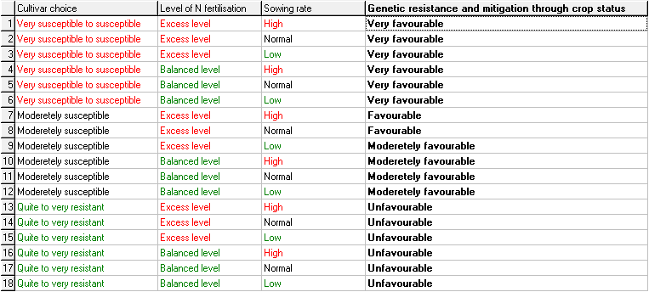

Resulting weights (calculated by DEXi):

83% 12% 5%